NEWSLETTER- KINDY LITTLE GROOVERS March 2018

It has been a really exciting start to the year with lots of enthusiastic little ones just keen and ready to dance!! All the Little Groovers are well and truly settled into their classes and we are having a ball. If your child ever starts to show disinterest in classes you will always be notified by myself.

Here is a little update. If you ever have any concerns or questions please do not hesitate to contact me.
I look forward to teaching and dancing with your child this year and creating many special memories!!

CONCERT
A Little Groovers concert will be held at your childcare centre!! This will be happening after Easter school holidays, around mid to end of May, early June. Dates to be advised soon.
The children perform routines and exercises they have been doing in class. This builds confidence & self esteem being able to dance in front of family and friends and you as parents can see your child’s progress. We understand parents are not present when their child is at kindergarten & do not see what they are doing in class, so this a great way for you to see what your child has been learning. They are provided with a costume and are lots of fun!!

They will also be invited to Little Groovers Mid Year Concert at Elanora Primary School 9th June 2pm where they perform one routine. This is optional and more information will be sent out closer to the time.

TERM DATES & HOLIDAYS
• We follow the QLD School Holiday Terms and no classes on public holidays. You are not invoiced for this

FEES
TERM 1 INVOICES ARE NOW DUE. Term 2 invoices will be emailed out in the Easter school holidays. If you have had problems receiving yours please let me know ASAP.
Due to some fees not being paid last year and lots of time spent chasing overdue fees I will be applying a 10% late fee for invoices not paid by due date.
If you have difficulty with payment other payment options can be made available as long as this is discussed with Little Groovers Dance Co. prior thereto then no late fee will be applied.

OPTIONAL UNIFORM
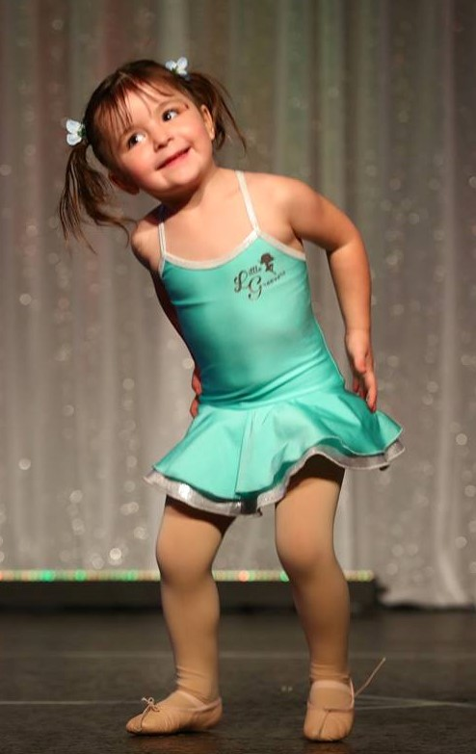
Little Groovers does have an optional uniform. For those that have not ordered one and would like one they are $42. This is what I pay for them. They are made here on the Gold Coast, fully lined and very good quality. Plus they are pretty cute. It is optional as I have had many requests for a uniform in the past we decided to introduce one. I have attached a picture of the dress.
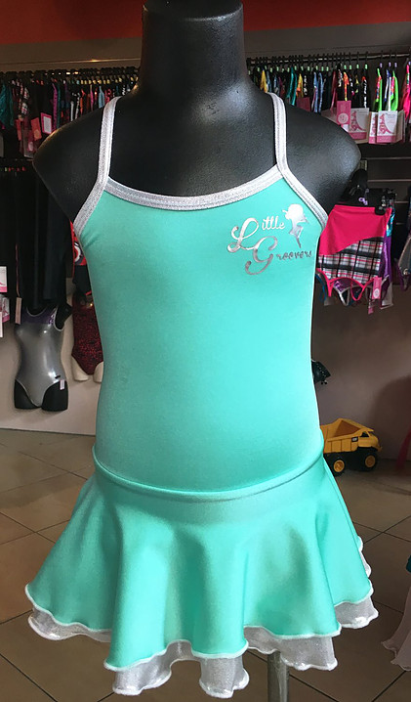
If you would like to order one please just send me an email and Ill get one organised for you.

FACEBOOK POSTS
When filling out an enrolment form you are asked to tick the box that says you are OK with pictures being posted to the Little Groovers Facebook Page and Website. I often like to post some class pictures or especially pictures at concert time. Parents do love this so family and friends can see their little one at dancing.
This is just another reminder could you please let me know if YOU DO NOT WANT PICTURES OF YOUR CHILD POSTED. I want to make sure I am doing the right thing by everyone.

AFTERNOON CLASSES
- I am often asked If I hold classes out of the kindy’s. For those that don’t know I hold Afternoon classes at Elanora Primary School from 2-12 years. Tiny Tot classes are Mondays, Thursday, and Fridays. If you would like more information please let me know.

LEARNING OUTCOMES AND WHATS HAPPENING IN CLASS
• Music is used which offers a wide variety of sounds & textures to help children develop a sense of rhythm, timing & musical appreciation. Also popular music which is familiar to the children to get them really enjoying themselves and to have fun!! (I am always asking them for their favourite songs!!)

• Dances and exercises which allow children to use their imagination develop self expression, creativity, control & co-ordination, physical fitness and transfer of weight. Gives them the opportunity to explore and experiment with their own ideas.

• Props are used to encourage children to move in different qualities and help them produce the movement we want them to get eg. Height and elevation

• Children learn basic dance disciplined behaviours such as waiting, taking turns, following instructions, working together and having a positive attitude.

• We will touch on some exercises from the Pre-Primary Royal Academy of Dance (RAD) Syllabus

DON’T FORGET If you have not liked our Facebook page please 'LIKE' Little Groovers Dance Co. at Facebook

MISS YVETTE xx

